-- Example.MIF

-- This code is modified to produce A = B + C + D

-- Leo Weng

-- ECE 2031 L01

-- 10/24/2016

DEPTH = 1024;

WIDTH = 16;

ADDRESS_RADIX = HEX;

DATA_RADIX = HEX;

CONTENT

BEGIN

[000..3FF] : 0000; -- Default to NOP

000 : 0411; -- Start: LOAD B ;Load value stored in B

001 : 0C12; -- ADD C ;Add value stored in C

002 : 0C13; -- ADD D ;Add value stored in D

003 : 0810; -- STORE A ;Store value in A

004 : 1404; -- Here: JUMP Here ;Loop here forever

010 : 0000; -- A: DW &H0000

011 : 0004; -- B: DW &H0004

012 : 0003; -- C: DW &H0003

013 : 0005; -- D: DW &H0005

END;

**Figure 1.** MIF code (example.MIF) modified from the given file to produce $A=(B+C)+D$.

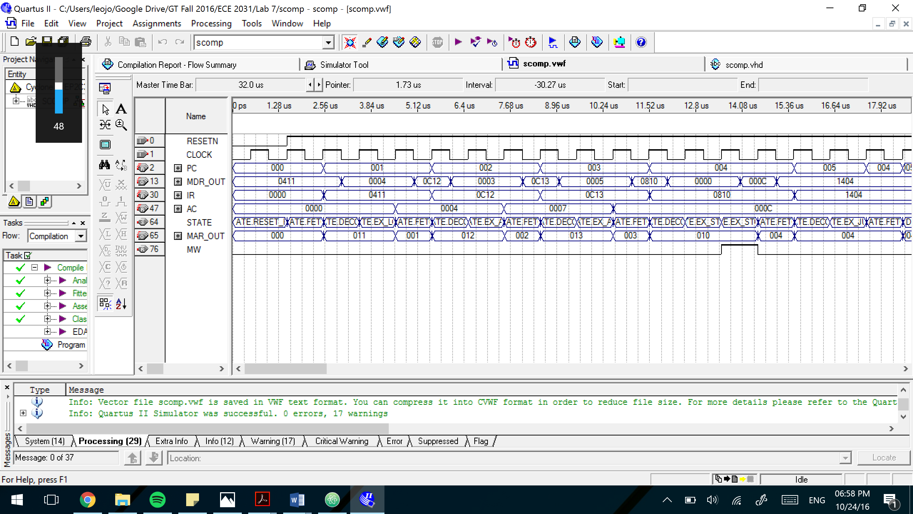

**Figure 2.** The timing simulation waveform for the Simple Computer computing $A=(B+C)+D$ and implementing example.MIF. The simple computer adds up B = 4, C = 3 and D = 5 and the result is saved in AC.

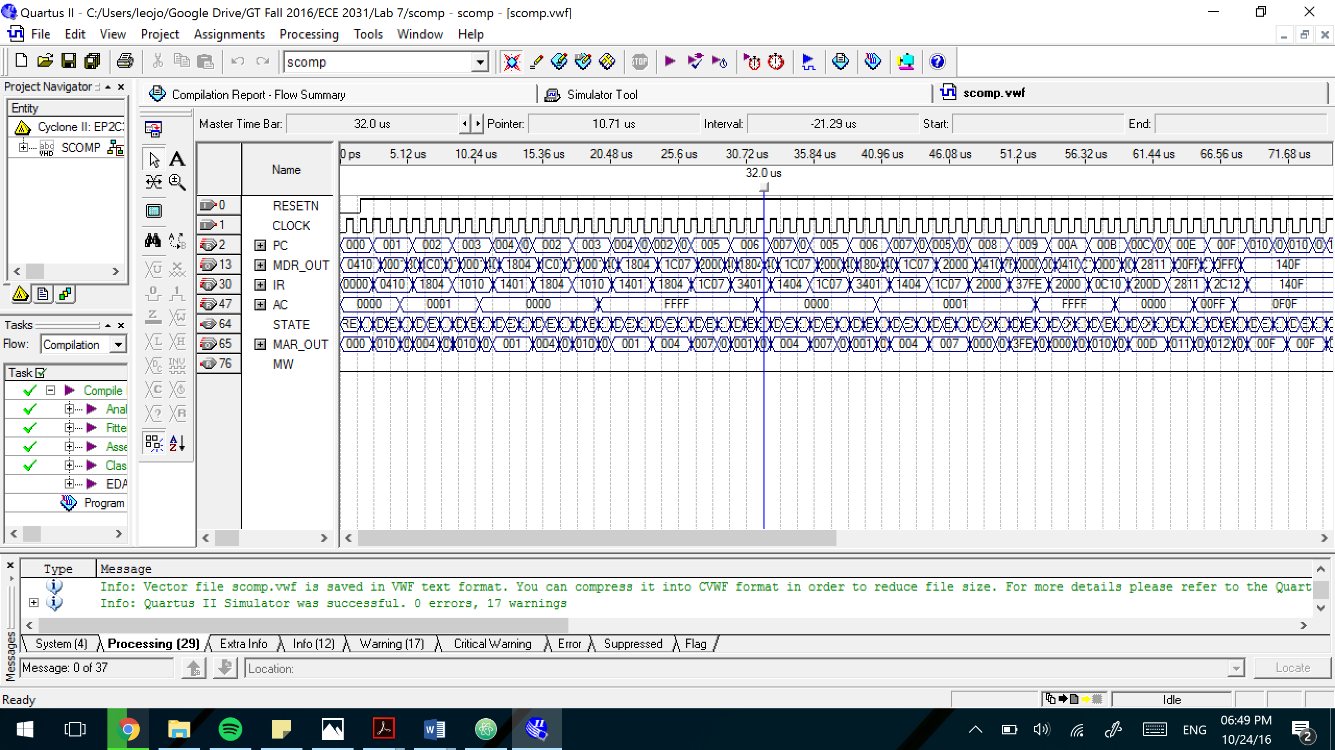

**Figure 3.** The timing simulation waveform for the Simple Computer implementing TEST_CASE.MIF. The AC should (and does) change from 1 -> 0 -> -1 -> 0 -> 1 -> -1 -> 0 -> 00FF -> 0F0F.

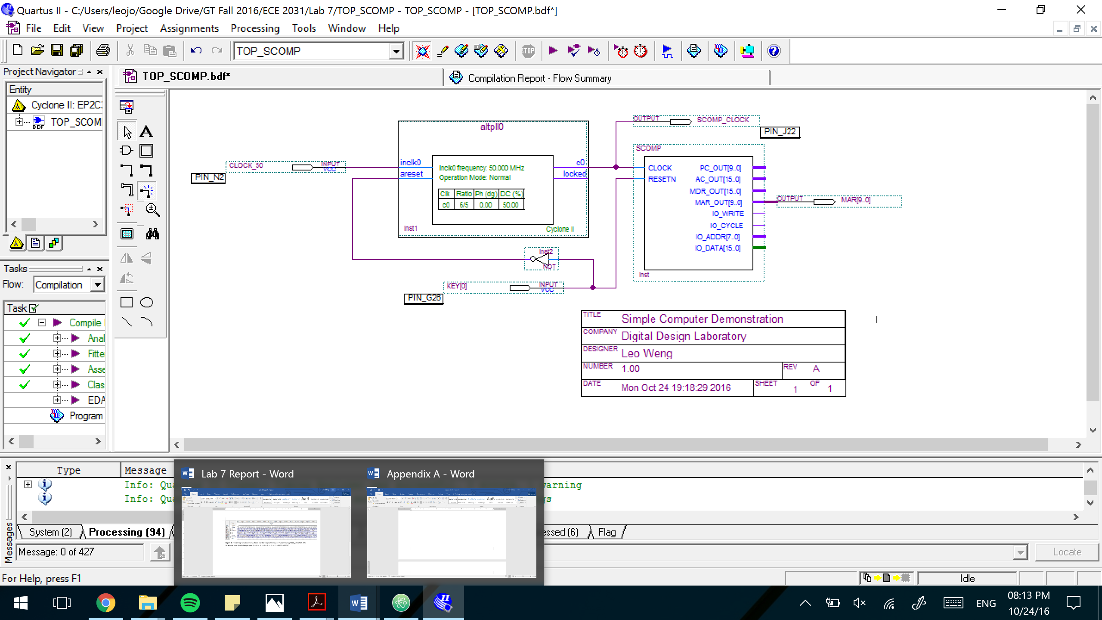

**Figure 4.** Schematic diagram including the simple computer (SCOMP) block that was created from the VHD file. Pin locations for the inputs and output are also shown.

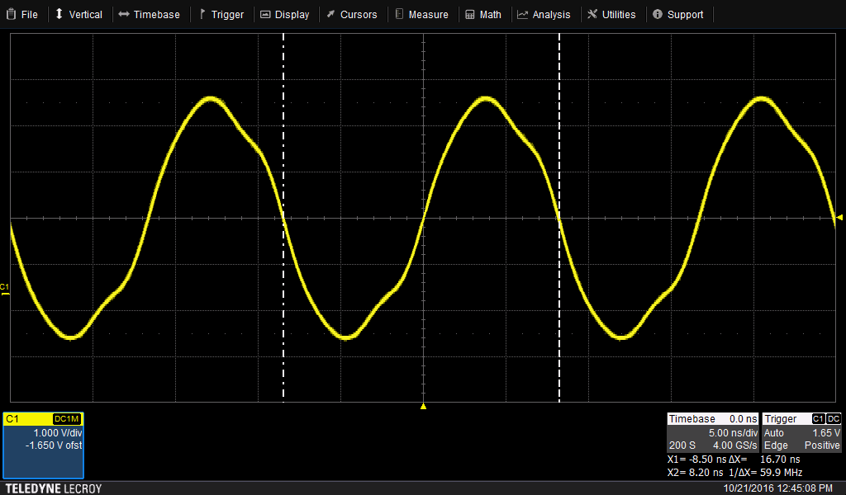

**Figure 5.** Oscilloscope screen capture of the simple computer with vertical triggers showing the period and frequency of the clock. The frequency of the clock is circled (59.9 MHz).